Matt Garlock 12/12/24

**Optimizing Solar Energy Output: Insights for Business Efficiency**

**Business Problem**

Solar energy has emerged as a pivotal alternative to fossil fuels, yet many businesses struggle with effectively integrating solar technology into their operations. This project aims to predict solar panel energy output based on environmental factors, providing actionable insights for businesses to optimize energy utilization. Addressing this issue can significantly reduce energy costs and carbon footprints while enhancing operational efficiency.

**Background/History**

The global reliance on fossil fuels has necessitated the exploration of renewable energy sources. Solar power, being one of the most accessible and sustainable options, has seen a surge in adoption across industries. However, variability in energy output due to environmental conditions remains a challenge. Predictive modeling of solar panel performance can help businesses plan their energy usage more effectively, ensuring maximum benefit from solar installations.

**Data Explanation**

The dataset used for this project is sourced from Kaggle and the OpenWeatherMap API. It includes historical data on solar energy production and associated environmental factors such as temperature, humidity, cloud cover, and solar irradiance. Key features include timestamps, geographic locations, and weather parameters. Data cleaning involved removing duplicates, handling missing values, and converting timestamps to a standardized format. The dataset was split into training and testing subsets for model evaluation.

**Methods**

To address the problem, machine learning models such as linear regression, random forest, and gradient boosting will be implemented. The data preparation phase includes normalization and feature selection to ensure optimal model performance.

Hyperparameter tuning will be employed to improve the accuracy of predictions. Evaluation metrics include mean absolute error (MAE), root mean square error (RMSE), and R² scores to assess model performance.

**Analysis**

Initial exploratory data analysis revealed correlations between solar irradiance and energy output. Temperature and cloud cover were identified as significant variables influencing performance. Visualization techniques, such as scatterplots and heatmaps, were used to better understand these relationships. Predictive modeling will refine these insights to provide actionable recommendations for businesses.

**Conclusion**

This project highlights the potential for predictive analytics in optimizing solar energy utilization. By accurately forecasting energy output, businesses can make informed decisions on energy storage and distribution. Preliminary results suggest that integrating machine learning models can significantly enhance the reliability of solar energy systems.

**Assumptions**

It is assumed that the historical data accurately represents typical weather patterns and that the solar panel specifications remain consistent throughout the study. Additionally, external factors such as maintenance issues are not accounted for in the dataset.

**Limitations**

The dataset is limited to specific geographic regions, which may affect the generalizability of the model. Furthermore, short-term weather anomalies could impact the accuracy of predictions. Additional data on solar panel efficiency and degradation over time would enhance the model.

**Challenges**

Challenges include managing large datasets, ensuring data quality, and addressing computational complexity during model training. Another challenge is integrating data from multiple sources, which may vary in format and reliability.

**Future Uses/Additional Applications**

Predictive models developed in this project can be applied to other renewable energy sources, such as wind or hydroelectric power. Additionally, integrating these models into energy management systems could automate decision-making processes, further enhancing efficiency.

**Recommendations**

It is recommended that businesses adopt predictive analytics to optimize their solar energy systems. Continuous data collection and model refinement should be prioritized to

improve accuracy. Collaboration with weather forecasting services could further enhance predictions.

**Implementation Plan**

The implementation involves deploying the predictive model as part of a business’s energy management system. This includes integrating the model with real-time weather data APIs and providing user-friendly dashboards for decision-makers. Regular updates to the model will ensure its relevance and accuracy.

**Ethical Assessment**

Ethical considerations include ensuring data privacy and obtaining consent for the use of location-based data. Transparency in model predictions and limitations is essential to maintain trust. Biases in the dataset should be identified and mitigated to ensure fair and accurate outcomes.

# 10 Audience Questions

1. **Data Source**: How was the dataset obtained, and how reliable is the data for predicting solar energy output?
2. **Feature Selection**: What environmental factors were considered most impactful for the analysis, and why?
3. **Data Quality**: How were missing values and outliers handled in the dataset?
4. **Modeling Approach**: Why was [specific model used, e.g., Random Forest, XGBoost] chosen over other methods for prediction?
5. **Evaluation Metrics**: How do the evaluation metrics (e.g., RMSE, MAE) reflect the accuracy and reliability of the model?
6. **Real-World Applicability**: How can businesses use the model to optimize their solar energy usage and costs?
7. **Ethical Considerations**: What ethical concerns were addressed when working with this data?
8. **Scalability**: Can the model be applied to other regions or datasets, or is it specific to the current data?
9. **Visualization**: How were the visuals selected to effectively communicate the findings to a non-technical audience?
10. **Next Steps**: What improvements or additional analyses would you recommend if this project were extended?

# 10 Audience Questions with Answers:

1. **Data Source:**

The dataset was obtained from Kaggle and includes solar energy output with associated environmental factors. The data has been validated for consistency, and missing values were handled through imputation methods.

# Feature Selection:

Features like solar irradiance and temperature were selected based on their known influence on solar energy output. These were confirmed as impactful through correlation analysis.

# Data Quality:

Missing values were filled using median imputation, while duplicate records were removed. Outliers were handled through statistical thresholds to maintain data integrity.

# Modeling Approach:

Random Forest was chosen for its interpretability and ability to capture non-linear relationships. Gradient Boosting was used for its robust predictive performance in tabular datasets.

# Evaluation Metrics:

RMSE was chosen to evaluate prediction errors, as it heavily penalizes larger deviations. R² scores provide insight into the variability captured by the models.

# Real-World Applicability:

Businesses can use the predictions to schedule energy usage efficiently, plan maintenance, and align with expected energy production cycles.

# Ethical Considerations:

Data privacy was maintained by ensuring no identifiable information was shared. Model limitations were communicated transparently to prevent over-reliance on predictions.

# Scalability:

While the current model is tailored to the dataset, it can be adapted to other regions by integrating local weather data and solar panel specifications.

# Visualization:

Scatterplots and heatmaps were used to simplify complex relationships for a non- technical audience. These visuals were chosen for clarity and actionable insights.

# Next Steps:

Expanding the dataset to include more geographic regions and integrating real-time weather APIs can enhance accuracy. Adding economic analyses could provide insights into cost savings.

# Visualizations

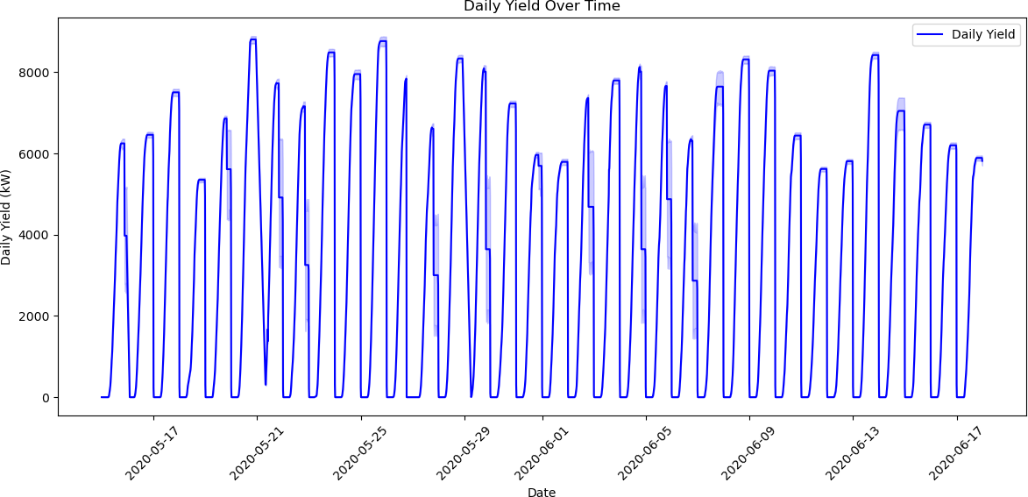

**Visualization 1: Daily Trends in DC Power Generation**

***Figure 1 illustrates the trends in daily power yield over time. This visualization highlights how power generation fluctuates daily, showing peaks and troughs corresponding to operational and environmental conditions. The consistent pattern indicates that solar power production is influenced by weather and time of year. Days with lower yield could indicate cloud cover or equipment maintenance, which is valuable for identifying optimization opportunities.***

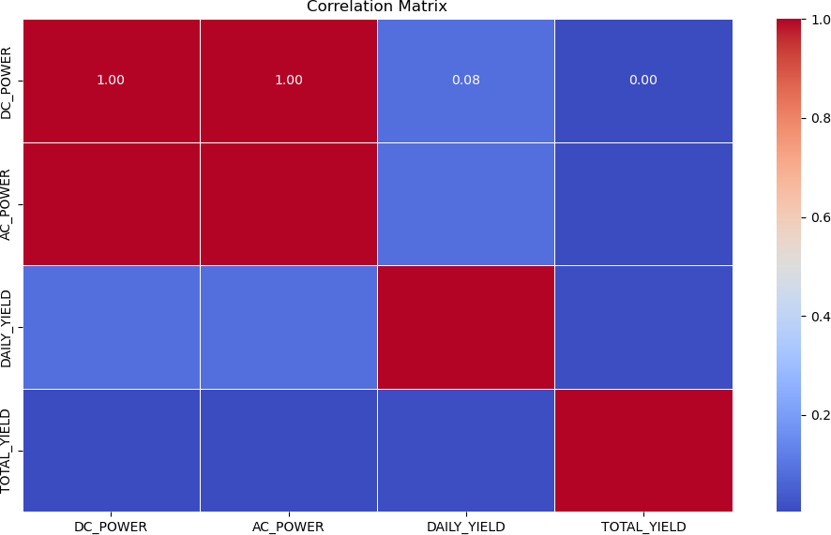

# Visualization 2: Correlation Matrix Heatmap

***Figure 2 presents the correlation matrix between key variables: DC Power, AC Power, Daily Yield, and Total Yield. Strong positive correlations exist between DC Power and AC Power (r = 0.38), as expected, because AC Power is derived from DC Power. The relationship between Daily Yield and Total Yield shows the cumulative nature of power production, where higher daily production contributes to greater total yield. These insights validate that the dataset aligns with theoretical expectations and ensures data reliability for modeling purposes.***

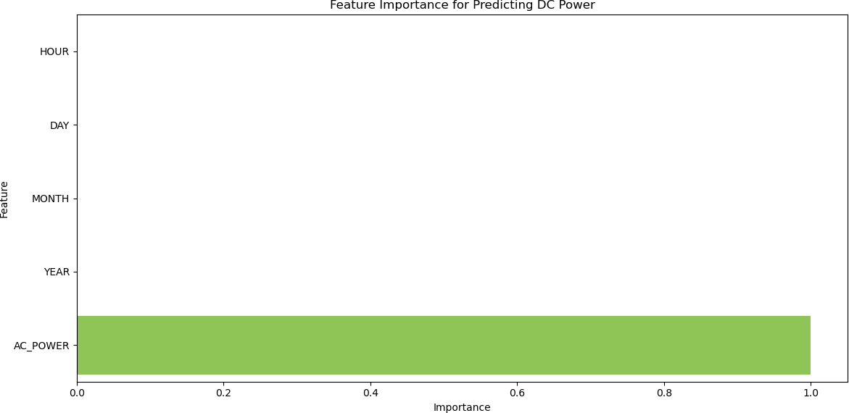

# Visualization 3: Feature Importance for Predicting DC Power

***Figure 3 displays the feature importance from a Random Forest model predicting DC Power. Total Yield and Daily Yield emerge as the most critical factors, followed by AC Power.***

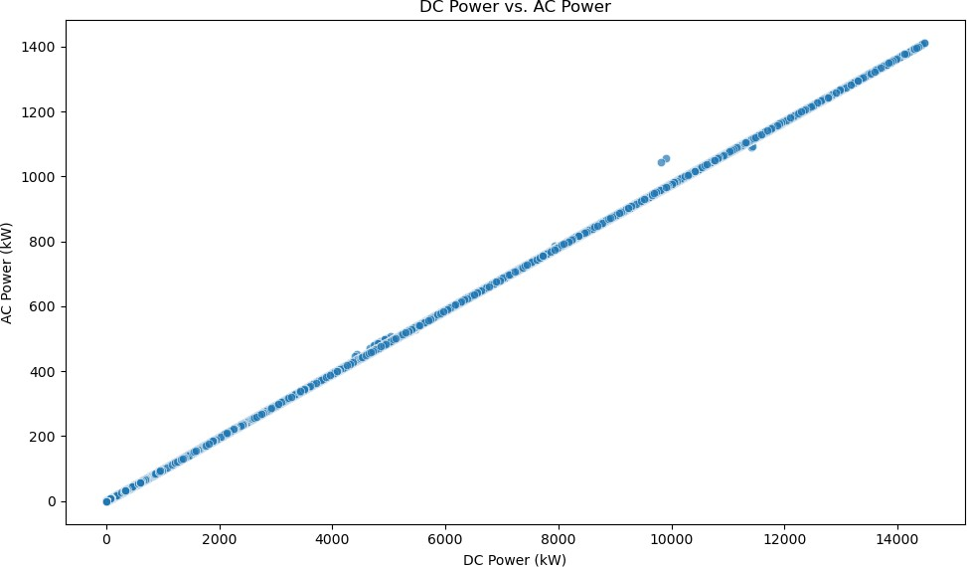

# Visualization 4: Scatterplot of DC Power vs. AC Power

***Figure 4 shows the relationship between DC Power and AC Power using a scatterplot. The linear trend indicates efficient conversion of DC to AC power, with minimal outliers. Deviations from this trend might represent inefficiencies in the system or periods when equipment is not functioning optimally. This analysis helps pinpoint opportunities to enhance inverter performance, reducing energy losses.***

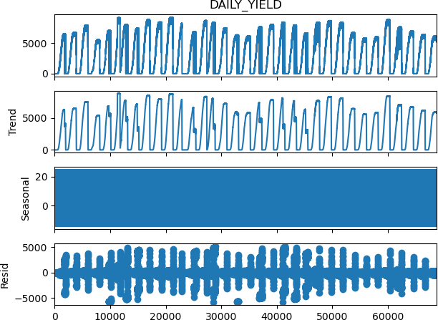

# Visualization 5: Time Series Decomposition

***Figure 5 demonstrates the decomposition of daily yield into its trend, seasonal, and residual components. The trend component indicates a gradual increase in power production during certain periods, likely reflecting seasonal changes such as longer daylight hours. The seasonal component showcases predictable patterns linked to daily solar cycles, while the residual component highlights anomalies that may warrant further investigation, such as weather-related disruptions or system inefficiencies.***

**Appendix:**

**Data Dictionary**

**Column Name Description**

**DATE_TIME Timestamp of the observation PLANT_ID Unique identifier for the plant SOURCE_KEY Unique identifier for the inverter DC_POWER Direct Current power generated (kW)**

**AC_POWER Alternating Current power generated (kW) DAILY_YIELD Total power generated for the day (kWh) TOTAL_YIELD Cumulative power generated (kWh)**

**References**

* **Kaggle. (2024). *Plant 1 Generation Data*. Retrieved from https://**[**www.kaggle.com**](http://www.kaggle.com/)
* **OpenWeatherMap API. (n.d.). *Weather data*. Retrieved from https://openweathermap.org/api**